Module – 4 (HIVE)

To switch off safe mode
Sudo –u hdfs hdfs dfsadmin –safemode leave
To create a data file
[cloudera@localhost ~]$ gedit data1;
1|ramu|20
2|krish|19
3|sita|20
4|john|21
5|syed|22

Save and Close

To connect to hive
[cloudera@localhost ~]$ hive

To create database
hive> create database db2;
(to drop database, drop database db2)

To see the list of databases
hive> show databases;

To make use of the database
hive> use db2;

To create table
hive> create table emp(id int,name string,age int)row format delimited fields
terminated by '|' lines terminated by '\n' stored as textfile;

To see the list of tables
hive> show tables;

To see the structure of a table
hive> describe emp;

To load data into hive table from local system
hive> load data local inpath '/home/cloudera/data1' into table emp;

To see the content of the table
hive> select * from emp;

To rename the table
alter table emp rename to employee;

To check the table names
hive> show tables;

To add new columns to the table
hive> alter table employee add columns(city string,pincode int);

To see the structure of a table
hive> describe employee;

To rename the column in a table
hive> alter table employee change city addr string;

To see the structure of a table
hive> describe employee;

To select the rows based on condition
hive> select * from employee where age>19;

To create a table from another table
hive> create table empd as select * from employee;
hive> select * from empd;

To limit the number of rows to be displayed
hive> select * from employee limit 2;

To use built-in functions
hive> select upper(name) from employee;
hive> select count(id) from employee;
hive> select substr(name,1,3) from employee;

To store the output of analysis to some other table
hive> insert overwrite table empd select * from employee where age>20;
hive> select * from empd;

To join two tables
hive> select * from employee e join empd d on (e.id=d.id);
hive> select * from employee e left outer join empd d on (e.id=d.id);
hive> select * from employee e right outer join empd d on (e.id=d.id);

To create a view
hive> create view emp_v as select id,name from employee;
hive> select * from emp_v;

To store the output of analysis to HDFS file system
hive> insert overwrite directory '/user/cloudera/output2'
select * from employee where age>20;

To store the output of analysis to Local file system
hive> insert overwrite local directory '/home/cloudera/output1'
select * from employee where age>20;

To quit from hive
hive> quit;

To check the output file in local system
[cloudera@localhost ~]$ ls output1;
[cloudera@localhost ~]$ cat output1/000000_0

To check the output file in Hadoop
[cloudera@localhost ~]$ hadoop fs -ls /user/cloudera/
[cloudera@localhost ~]$ hadoop fs -cat /user/cloudera/output1/000000_0
(or)
Through Browser

MODULE 4
HIVE
TO SWITCH OFF SAFE MODE
$ sudo –u hdfs hdfs dfsadmin –safemode leave

EXP 20: DDL Commands
To Create Two Files On Local Filesystem And Copy It To Hdfs Any Folder
[cloudera@localhost ~]$ gedit emp.txt
1001|hari|d1|chennai|1986-12-10
1002|teja|d1|hyd|1987-01-21
1003|ram|d3|delhi|1986-02-11
1004|milind|d4|bang|1988-03-21
1005|jay|d2|bang|1988-03-22
1006|naveen|d4|hyd|1986-04-12
1007|naser|d1|hyd|1989-11-15
1008|rahul|d3|delhi|1990-12-23

[cloudera@localhost ~]$ gedit d.txt
d1|research|A-block
d2|sales|A-block
d3|testing|B-block
d4|development|C-block

[cloudera@localhost ~]$ hadoop fs -put emp.txt /user/cloudera/batch3
[cloudera@localhost ~]$ hadoop fs -put d.txt /user/cloudera/batch3
CONNECT TO HIVE
[cloudera@localhost ~]$ hive
hive>

TO CREATE DATABSE
hive> ok; (OR)
hive> create database if not exists test;

TO LIST OUT DATABSES
hive> show databases;

TO DROP DATABSE
hive> drop database test; (OR)
hive> drop database if exists test; (OR)
hive> drop database if exists test cascade;

NOTE!!!! [if exists] & [if not exists] doesn’t show error if database already exists while creating time and database doesn’t exists while dropping the same.
Without these options , errors displayed clearly.

TO MAKE USE OF THE DATABASE
hive> use test;
Create Table Statement
Create Table is a statement used to create a table in Hive. The syntax and example are as follows:
Syntax
CREATE [TEMPORARY] [EXTERNAL] TABLE [IF NOT EXISTS] [db_name.] table_name
[(col_name data_type [COMMENT col_comment], ...)]
[COMMENT table_comment]
[ROW FORMAT row_format]
[STORED AS file_format]

TO CREATE TABLE
hive> create table emp(id int,name string,dept string,place string,dob string)
>comment ‘this is employee table’
> row format delimited fields terminated by '|' lines terminated by '\n'
>stored as textfile;

(OR) Type IN Single Line

hive> create table emp(id int,name string,dept string,place string,dob string) comment ‘this is employee table’ row format delimited fields terminated by '|' lines terminated by '\n' stored as textfile;

hive> create table department(did string,dname string,block string) comment 'this is department table' row format delimited fields terminated by '|' lines terminated by '\n' stored as textfile;
NOTE!!! You can mention just mention
Hive>USE test;
Hive> CREATE TABLE emp (…..) ….
(OR)
Hive> CREATE TABLE test.emp (……) ….

TO SEE THE LIST OF TABLES
hive> show tables;

TO SEE THE STRUCTURE OF A TABLE
hive> describe emp;

TO SEE THE STRUCTURE & METADATA INFORMATION OF TABLE
hive> describe formatted emp;
hive> show create table emp;
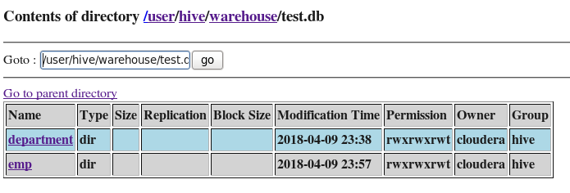
Alter Table Statement
It is used to alter a table in Hive.
Syntax
The statement takes any of the following syntaxes based on what attributes we wish to modify in a table.
ALTER TABLE name RENAME TO new_name
ALTER TABLE name ADD COLUMNS (col_spec[, col_spec ...])
ALTER TABLE name CHANGE column_name new_name new_type
ALTER TABLE name REPLACE COLUMNS (col_spec [, col_spec ...])

TO RENAME TABLE NAME
hive> alter table department rename to d;
hive> show tables;
d
emp

TO ADD ONE OR MORE COLUMNS TO THE TABLE
hive> alter table d add columns (estb_year int,rating smallint);
hive> describe d;
did string
dname string
block string
estb_year int
rating smallint
TO CHANGE COLUMN NAME OR ITS DATATYPE OR BOTH
hive> alter table d change rating rate string;
hive> describe d;
did string
dname string
block string
estb_year int
rate string

hive> alter table d change rate rate bigint;
hive> describe d;
did string
dname string
block string
estb_year int
rate bigint

TO REPLACE COLUMNS
hive> alter table d replace columns (did string,dname string, block string);
hive> describe d;
did string
dname string
block string

hive> alter table d replace columns (block string);
hive> describe d;
block string

hive> select * from d;
d1
d2
d3
d4
//if you do REPLACE again, you will get the columns again I,e replace is not removing columns permanently

hive> alter table d replace columns (did string,dname string, block string);
hive> desc d;
did string
dname string
block string

hive> select * from d;
d1 research A-block
d2 sales A-block
d3 testing B-block
d4 development C-block
d5 hr A-block

TO DROP THE TABLE
hive> drop table if exists d; (OR)
hive> drop table d;

EXP 21: Load, Insert of data
Load Data Statement
Generally, after creating a table in SQL, we can insert data using the Insert statement. But in Hive, we can insert data using the LOAD DATA statement.
While inserting data into Hive, it is better to use LOAD DATA to store bulk records. There are two ways to load data: one is from local file system and second is from Hadoop file system.
Syntax
The syntax for load data is as follows:

LOAD DATA [LOCAL] INPATH 'filepath' [OVERWRITE] INTO TABLE tablename
[PARTITION (partcol1=val1, partcol2=val2 ...)]
LOCAL is identifier to specify the local path. It is optional.
OVERWRITE is optional to overwrite the data in the table.
PARTITION is optional used table is created with partitions.
TO LOAD FROM LOCAL FILESYSTEM
hive> load data local inpath '/home/cloudera/emp.txt' into table emp;
hive> select * from emp;
1001 hari d1 chennai 1986-12-10
1002 teja d1 hyd 1987-01-21
1003 ram d3 delhi 1986-02-11
1004 milind d4 bang 1988-03-21
1005 jay d2 bang 1988-03-22
1006 naveen d4 hyd 1986-04-12
1007 naser d1 hyd 1989-11-15
1008 rahul d3 delhi 1990-12-23
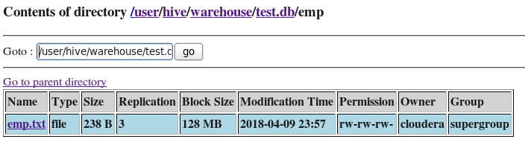

TO LOAD FROM HADOOP FILE SYSTEM
hive> load data inpath '/user/cloudera/emp.txt' into table emp;
hive> select * from emp;
1001 hari d1 chennai 1986-12-10
1002 teja d1 hyd 1987-01-21
1003 ram d3 delhi 1986-02-11
1004 milind d4 bang 1988-03-21
1005 jay d2 bang 1988-03-22
1006 naveen d4 hyd 1986-04-12
1007 naser d1 hyd 1989-11-15
1008 rahul d3 delhi 1990-12-23
1001 hari d1 chennai 1986-12-10
1002 teja d1 hyd 1987-01-21
1003 ram d3 delhi 1986-02-11
1004 milind d4 bang 1988-03-21
1005 jay d2 bang 1988-03-22
1006 naveen d4 hyd 1986-04-12
1007 naser d1 hyd 1989-11-15
1008 rahul d3 delhi 1990-12-23
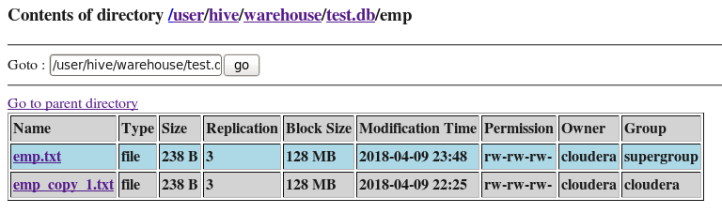
NOTE!!!!Here, Since no overwrite was used; the data got appended to same table. And in Hive/warehouse/test.db two copies of same content got generated.

TO LOAD USING OVERWRITE KEYWORD
hive> load data local inpath '/home/cloudera/emp.txt' overwrite into table emp;
hive> select * from emp;
1001 hari d1 chennai NULL
1002 teja d1 hyd NULL
1003 ram d3 delhi NULL
1004 milind d4 bang NULL
1005 jay d2 bang NULL
1006 naveen d4 hyd NULL
1007 naser d1 hyd NULL
1008 rahul d3 delhi NULL

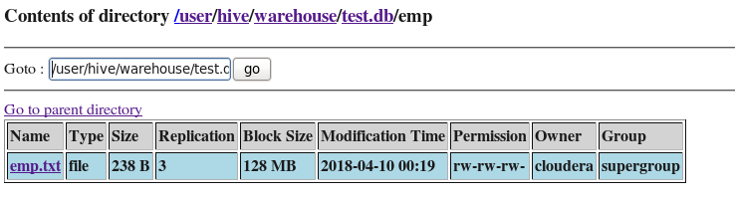
NOTE!!! Once the data is loaded to hive table from hadoop filesystem, the file “emp.txt” no more exists in /user/cloudera I,e loading from hadoop filesystem is like cut and paste to hive; whereas its like copy & paste when loaded from local filesystem.

So , if you have loaded from hadoop filesytem once, then you can’t load or load with overwrite to hive table from hadoop filesystem again…. Because you will get ERROR: “invalid path as file is cut already from that location.”

hive> load data local inpath '/home/cloudera/d.txt' overwrite into table department;
hive> select * from department;
d1 research A-block
d2 sales A-block
d3 testing B-block
d4 development C-block
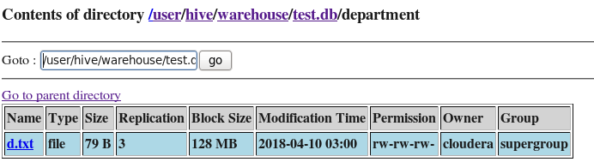

EXP 22: BUILT_IN RELATIONAL OPERATORS
A=B, A<B, A<=B, A>B, A>=B, A IS NULL, A IS NOT NULL, A LIKE B, A!=B

BUILT_IN ARTHEMATIC OPERATORS
A+B, A-B, A*B, A/B, A%B, A&B, A|B, A^B, ~A
A&B : bitwise and operation
A|B: bitwise or operation
A^B;bitwise XOR operation
~A: bitwise not operation

BUILT_IN LOGICAL OPERATORS
A AND B, A OR B, NOT A, A || B, A&&B, !A

Q)Display details of employee whose employee id is greater than and equal to 1003 and doesn’t come from hyd.
hive> select * from emp where id >=1003 and place !='hyd'; (OR)
hive> select * from emp where id >=1003 and place not in ('hyd');
1003 ram d3 delhi 1986-02-11
1004 milind d4 bang 1988-03-21
1005 jay d2 bang 1988-03-22
1008 rahul d3 delhi 1990-12-23

Q)Display details of department whose id is less than d2 or department name is development.
hive> select * from department where did<'d2' or dname='development'; (OR)
hive> select * from department where did<'d2' or dname like 'development'; (OR)
hive> select * from department where did<'d2' or dname like 'd%';
d1 research A-block
d4 development C-block

Q)Display details of department whose department name’s second letter is ‘e’.
hive> select * from department where did<'d2' or dname like '_e%';
d1 research A-block
d3 testing B-block
d4 development C-block

Q)Display total no:of employees ,minimum of their employee no, avg of their employee no,max of their employee, sum of their employee from employee dataset.
hive> select count(*),min(id),avg(id),max(id),sum(id) from emp;
8 1001 1004.5 1008 8036
Q) Display department id, count of employees in each department
hive> select count(*),dept from emp group by dept;
3 d1
1 d2
2 d3
2 d4

Q) Display department id,count of employees in each department and display rows those have count more than 2.
hive> select count(*),dept from emp group by dept having count(*)>2;
3 d1

Q) Display department id,count of employees in each department in descending order of count.
hive> select count(*) as c,dept from emp group by dept order by c desc;
3 d1
2 d3
2 d4
1 d2

Q) Display department id,count of employees in each department in descending order of count and display only first two rows.
hive> select count(*) as c,dept from emp group by dept order by c desc limit 2;
3 d1
2 d3

EXP 23: TO JOIN TWO TABLES
hive> select * from emp e join department d on (e.dept=d.did);
001 hari d1 chennai 1986-12-10 d1 research A-block
1002 teja d1 hyd 1987-01-21 d1 research A-block
1007 naser d1 hyd 1989-11-15 d1 research A-block
1005 jay d2 bang 1988-03-22 d2 sales A-block
1003 ram d3 delhi 1986-02-11 d3 testing B-block
1008 rahul d3 delhi 1990-12-23 d3 testing B-block
1004 milind d4 bang 1988-03-21 d4 development C-block
1006 naveen d4 hyd 1986-04-12 d4 development C-block
hive> select * from emp e left outer join department d on (e.dept=d.did);
1001 hari d1 chennai 1986-12-10 d1 research A-block
1002 teja d1 hyd 1987-01-21 d1 research A-block
1007 naser d1 hyd 1989-11-15 d1 research A-block
1005 jay d2 bang 1988-03-22 d2 sales A-block
1003 ram d3 delhi 1986-02-11 d3 testing B-block
1008 rahul d3 delhi 1990-12-23 d3 testing B-block
1004 milind d4 bang 1988-03-21 d4 development C-block
1006 naveen d4 hyd 1986-04-12 d4 development C-block
1009 jay d6 hyd 1988-07-19 null null null

NOTE!!if d6 department not there ,then no matching on right side table values
hive> select * from emp e right outer join department d on (e.dept=d.did);
1001 hari d1 chennai 1986-12-10 d1 research A-block
1002 teja d1 hyd 1987-01-21 d1 research A-block
1007 naser d1 hyd 1989-11-15 d1 research A-block
1005 jay d2 bang 1988-03-22 d2 sales A-block
1003 ram d3 delhi 1986-02-11 d3 testing B-block
1008 rahul d3 delhi 1990-12-23 d3 testing B-block
1004 milind d4 bang 1988-03-21 d4 development C-block
1006 naveen d4 hyd 1986-04-12 d4 development C-block
NULL NULL NULL NULL NULL d5 hr A-block

EXP 24: TO CREATE A VIEW
hive> create view emp_v as select id,name from emp where id>1003;
hive> select * from emp_v;
1004 milind
1005 jay
1006 naveen
1007 naser
1008 rahul

TO DROP THE VIEW
hive>drop view emp_v;

To Use Built-In Functions

hive> select upper(name) from emp;
HARI
TEJA
RAM
MILIND
JAY
NAVEEN
NASER
RAHUL

hive> select count(id) from emp;
8

hive> select substr(name,1,3) from emp;
har
tej
ram
mil
jay
nav
nas
rah

hive> select substr(name,2) from emp;
ari
eja
am
ilind
ay
aveen
aser
ahul

hive> select substr(name,3,2) from emp;
ri
ja
m
li
y
ve
se
hu
Syntax: substr(string,starting index,no of character)
Note: if no of characters not mentioned then it returns from the start position to the end of the string
TO CREATE A TABLE FROM ANOTHER TABLE
hive> create table abc as select * from emp;
hive> select * from abc;

TO STORE THE OUTPUT OF ANALYSIS TO SOME OTHER TABLE
hive> insert overwrite table abc select * from emp where id>1003;
hive> select * from abc;
004 Milind D4 Bang 1988-03-21
1005 Jay D2 Bang 1988-03-22
1006 Naveen D4 Hyd 1986-04-12
1007 Naser D1 Hyd 1989-11-15
1008 Rahul D3 Delhi 1990-12-23

Note:schema should match(No.of column should match)

To Store The Output Of Analysis To Hdfs File System
Hive> Insert Overwrite Directory '/User/Cloudera/Output1' Select * From Emp Where Id>1003;
Note!! Where Output1 Is A New Directory In /User/Cloudera, Which Will Get Created Automatically

To Check The Output File In Hadoop File System
[Cloudera@Localhost ~]$ Hadoop Fs -Ls /User/Cloudera/Output1
[Cloudera@Localhost ~]$ Hadoop Fs -Cat /User/Cloudera/Output1/00000_0
(Or)
Hive> Dfs -Ls /User/Cloudera/Output1;
-Rw-R--R-- 3 Cloudera Supergroup 149 2018-04-17 03:32 /User/Cloudera/Output1/000000_0

Hive> Dfs -Cat /User/Cloudera/Output1/0*;
1004milindd4bang1988-03-21
1005jayd2bang1988-03-22
1006naveend4hyd1986-04-12
1007naserd1hyd1989-11-15
1008rahuld3delhi1990-12-23
(Or)
Use Browser Of Your Vm To Go To The Location And Verify The File
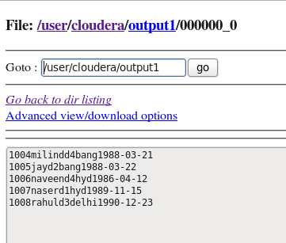

TO STORE THE OUTPUT OF ANALYSIS TO LOCAL FILE SYSTEM
hive> insert overwrite local directory '/home/cloudera/output1' select * from employee where id>1003;

TO CHECK THE OUTPUT FILE IN LOCAL SYSTEM
[cloudera@localhost ~]$ ls
[cloudera@localhost ~]$cd output1
[cloudera@localhost ~]$ cat 000000_0 (OR) $gedit 000000_0
(OR)
[cloudera@localhost ~]$ ls output1
[cloudera@localhost ~]$ cat output1/000000_0
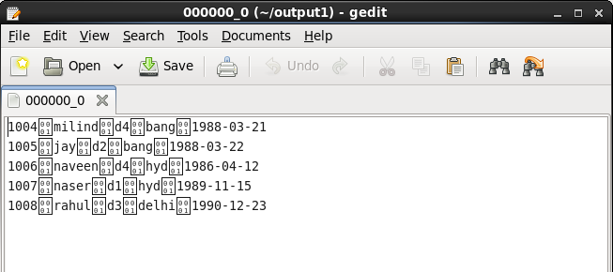
TO QUIT FROM HIVE
hive> quit;

